39.20: a) 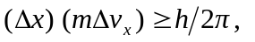and setting 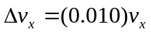and the product of the uncertainties equal to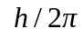 (for the minimum uncertainty) gives 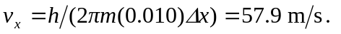
b) Repeating with the proton mass gives 31.6 